General notes:

When clicking any internal link, if you are say 50% down a page, you are taken the that point on the new page, not to the top of the new page.

Navigation - header

- Scale not right
- Logo blurry
- Remove CM Slim, Unisome, Vanquish from treatment list
- Remove the London and Edinburgh item between phone number and translation
- Change doctors to team
- Remove the all locations page ( don’t think we need it and the dropdown for both )
- Phone number not clickable
- Please update treatments in navigation as per this layout - https://docs.google.com/spreadsheets/d/1A5tXjtgaK7M7UIkLq2oTHI399k_Ra9Nwe2y5jUVTtQ0/edit?gid=442914769#gid=442914769
- Add Book Now Menu - Pref as a standout button

Navigation - footer

- Book goes to wrong link
- Says Aesthetic Lab not Beyond Aesthetic Clinic
- Incorrect contact info
- phone and email not clickable
- Policy / T&C don’t go anywhere yet
- Social links not working
- https://www.instagram.com/beyond.aesthetic.clinic/
- https://www.facebook.com/BeyondAestheticClinicUK/
- https://www.youtube.com/@beyondmedispa2049

- 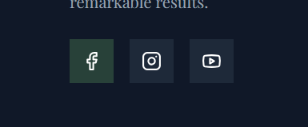

Homepage

- Legally need CQC logo on the page - can be in footer

Format -

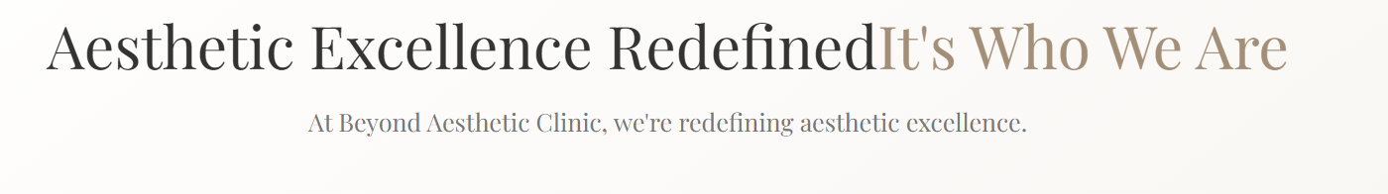
- Information here isn’t accurate, can we just have an image?
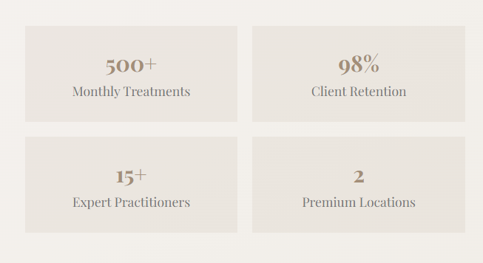

- Can this section match the london treatments tab? So we have body, peels, facials, injectables
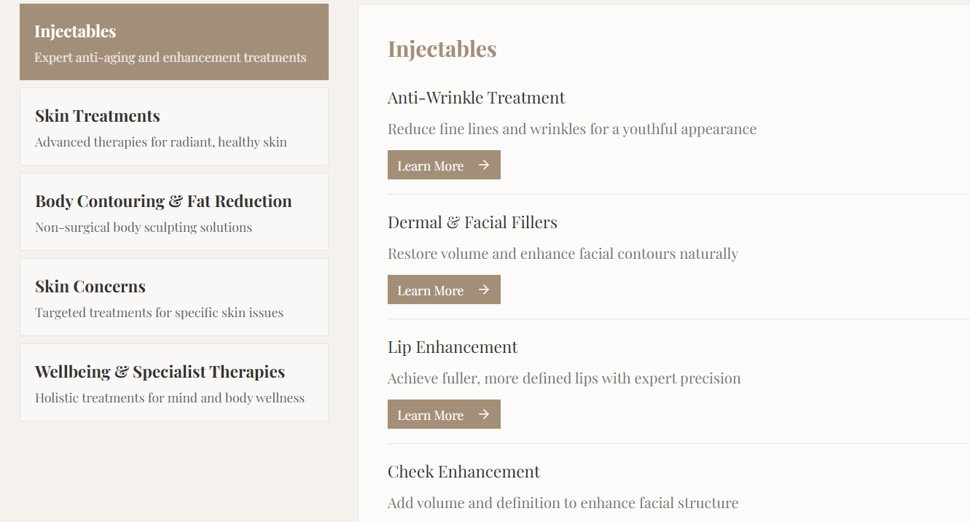

- Icons not loading

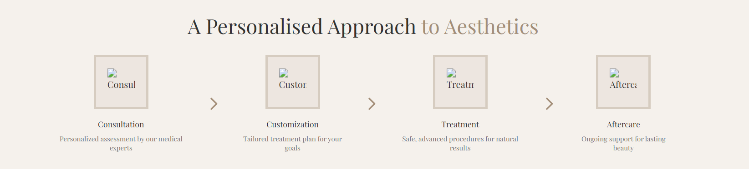

- Remove this section

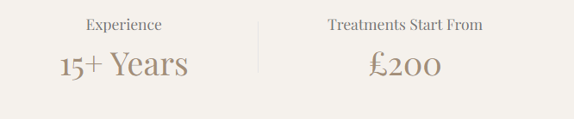

- Remove parking from location areas
- Take out this section from review please, dont know how accurate it is
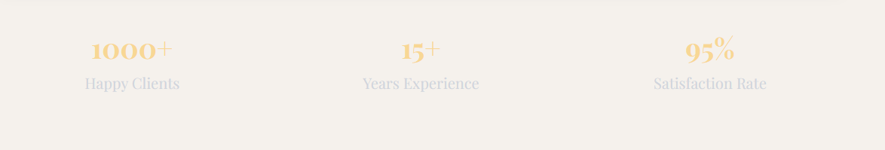

- Book appointment buttons on locations don’t work
- Remove view all treatments button from procedures list section
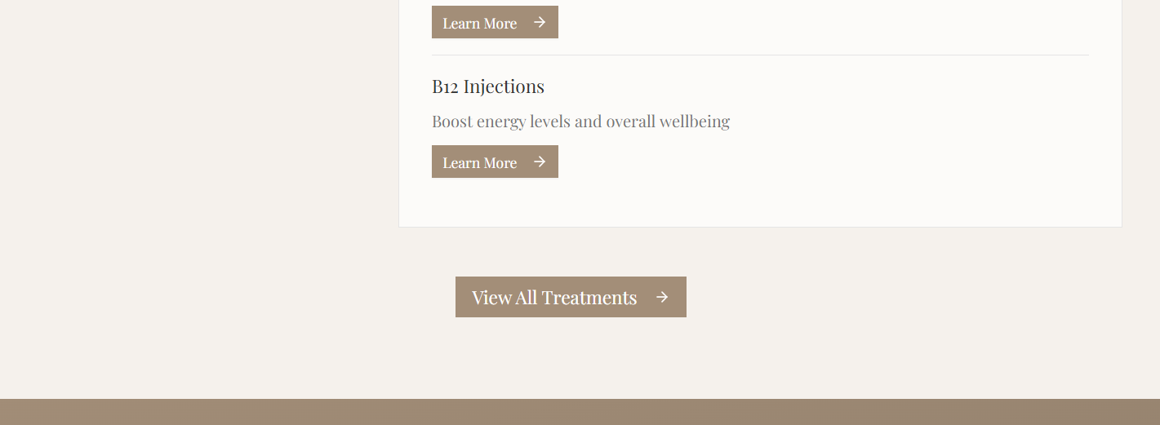

About Page

- Marianne is a Nurse Prescriber
- Image load fail
- 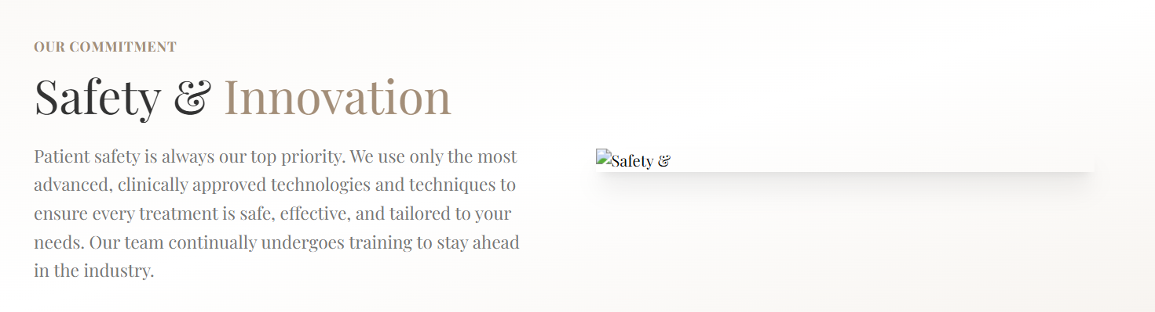
- All staff images fail to load
- Don’t need both of these - I’d keep where to find us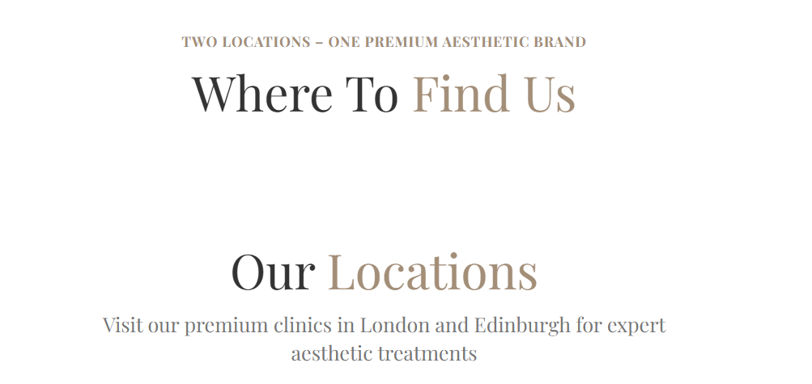
- Formatting is off, very narrow compared to map elements on other pages
- 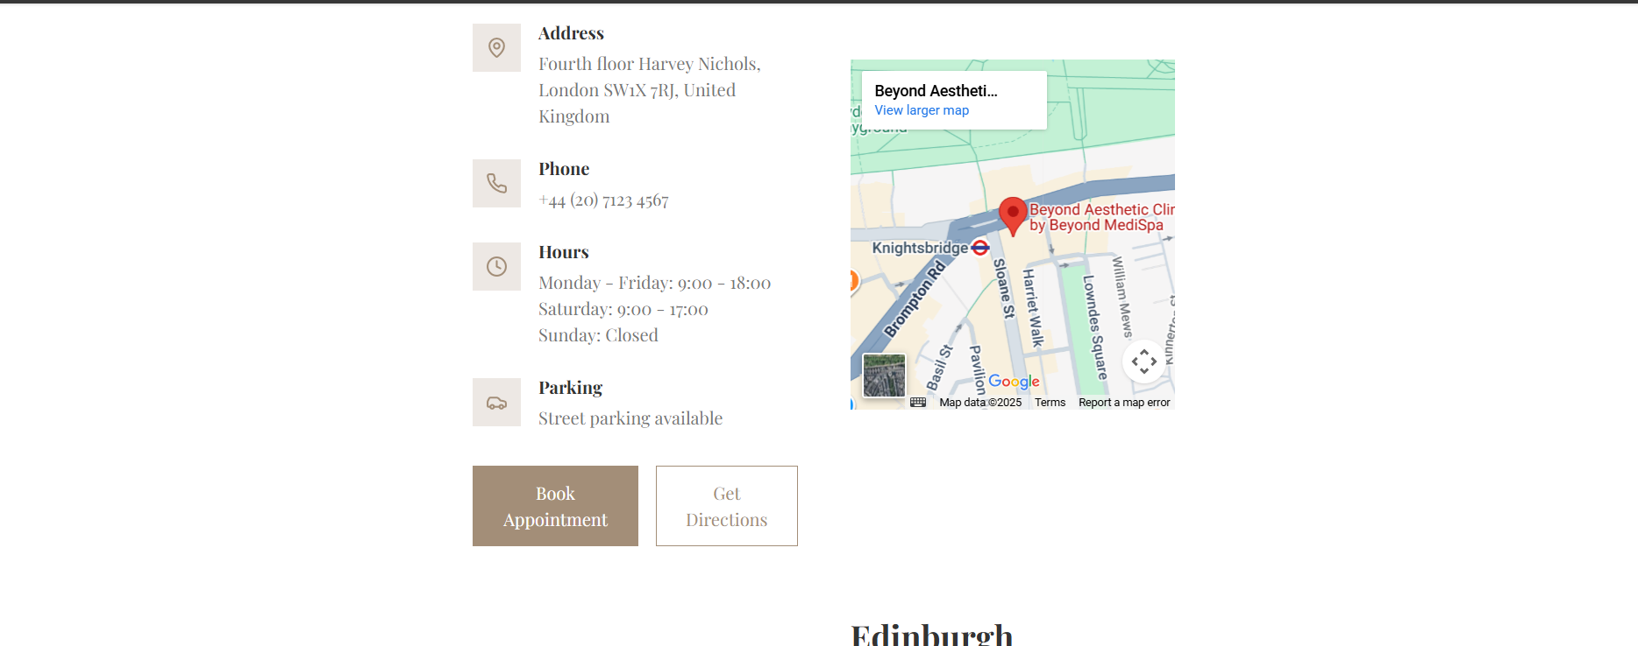
- Book appointment buttons don’t work

Top level treatment pages

https://www.beyondmedispa.com/london/body
https://www.beyondmedispa.com/london/peels
https://www.beyondmedispa.com/london/facial
https://www.beyondmedispa.com/london/injectables
https://www.beyondmedispa.com/edinburgh/body
https://www.beyondmedispa.com/edinburgh/peels
https://www.beyondmedispa.com/edinburgh/facial
https://www.beyondmedispa.com/edinburgh/injectables

- Pricing not right, available here https://docs.google.com/spreadsheets/d/1A5tXjtgaK7M7UIkLq2oTHI399k_Ra9Nwe2y5jUVTtQ0/edit?gid=709879543#gid=709879543
- Remove CM Clim, Vanquish and Unisom as with Nav

Doctors page - https://www.beyondmedispa.com/doctors

All info for team is available here, please take and replicate to current style for all team members - https://book.beyondmedispa.com/team

Contact Page

- Links are not active in CTA box

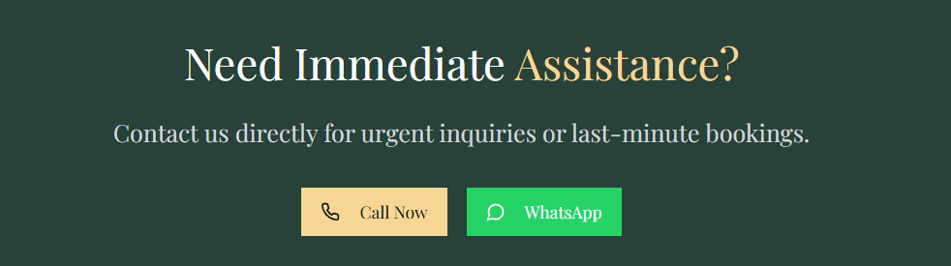

- Wrong email
- Book now buttons are not active

- 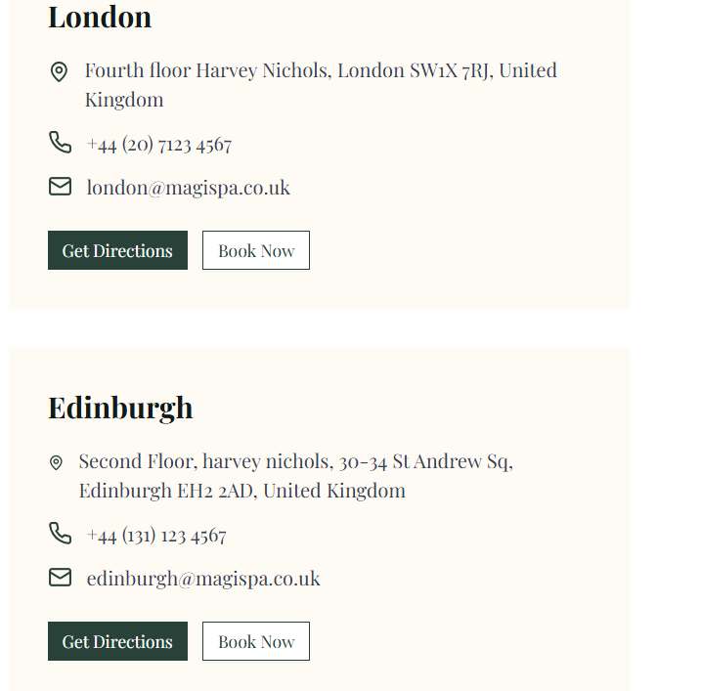

Individual Procedure pages

All pages need to follow the copy docs as listed in this document - right now they have placeholder content

Beyond Content Links

